Acceptance Testing

# Story C-2: How to Order

As a customer, I want to know how the business processes my order so that I can place an order and have it delivered before a specific time.

## Acceptance Criteria

A tab will be added to the website which will be available to everyone, regardless if they have an account or not. This tab will open a how to page, including contact details for further queries.

## Test 1

When not logged into an account, the user can view the ‘How To’ tab.

### Evidence

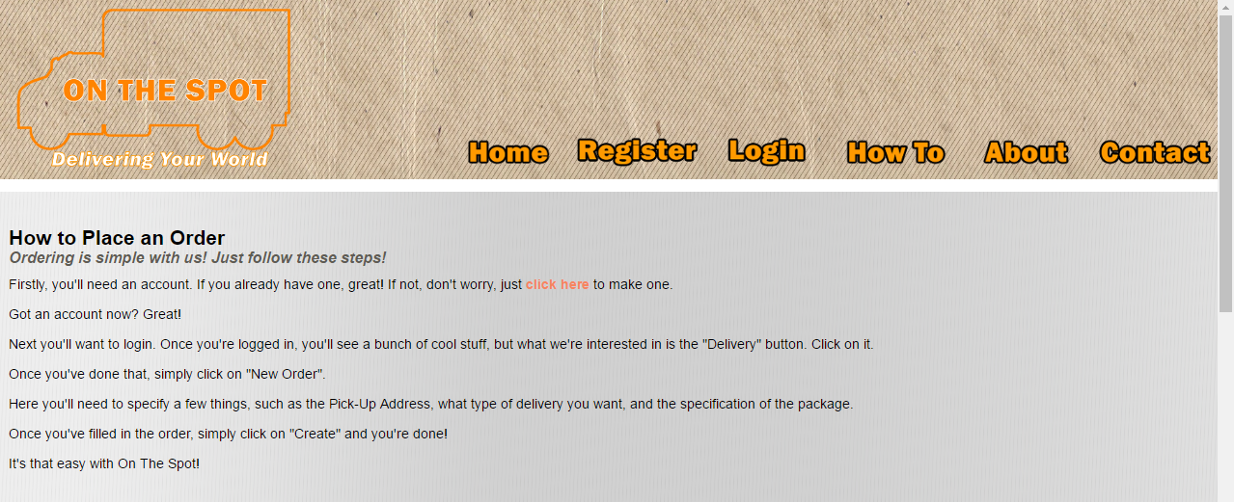

### Result

Pass – the user can view the ‘How To’ tab without having an active account

## Test 2

When logged into an account, the user can view the ‘How To’ tab.

### Evidence

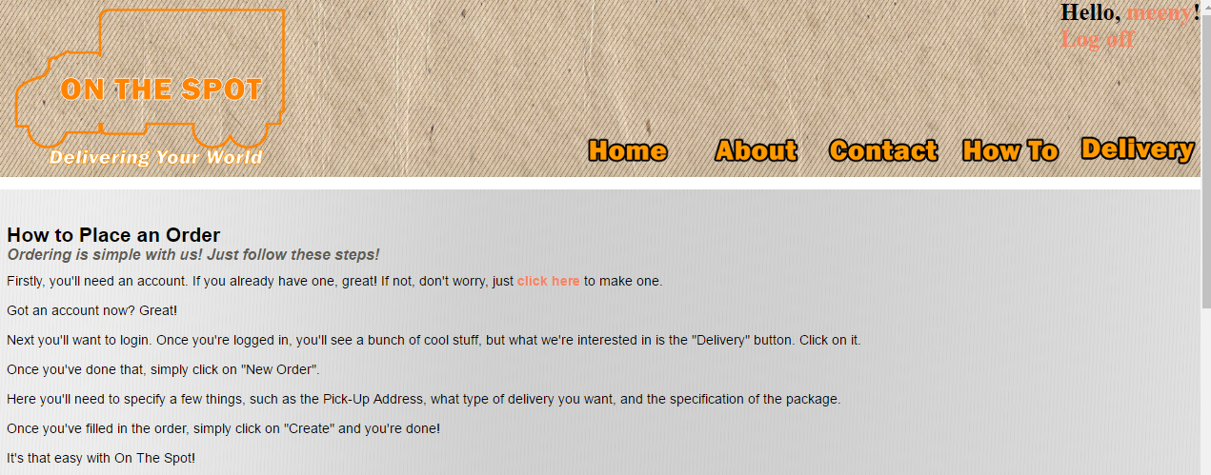

### Result

Pass – The ‘How To’ tab is viewable when logged in (as a customer).

## Overall Results

Test 1 – Pass  
Test 2 – Pass

Story C-2 consisted of two tests and both tests passed, meaning Story C-2 has been successfully implemented.

# Story E-6: Available Vehicles

As a courier, I want to know which vehicles are available for my use so that I can deliver packages more efficiently (i.e. use a truck to deliver multiple to the same location, large packages).

## Acceptance Criteria

Able to see a page displaying personal vehicle of courier and all company vehicles  
Able to book a vehicle and see whether a specific vehicle is unavailable

## Test 1

When logged in as a courier, the user is able to see which vehicles are available and unavailable

### Evidence

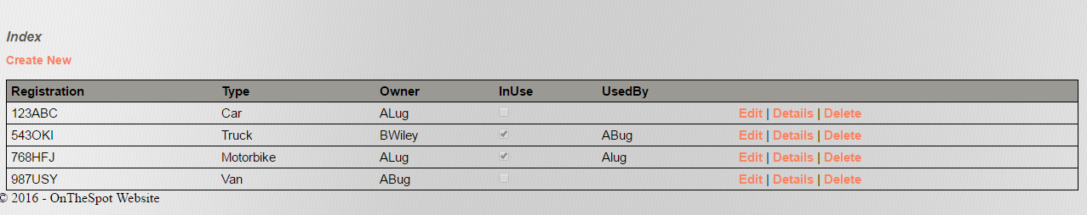

### Result

Pass – In the ‘Vehicles’ tab the courier can view the vehicles available or in use.

## Test 2

When logged in as courier, the user is able to book vehicles for their delivery.

### Evidence

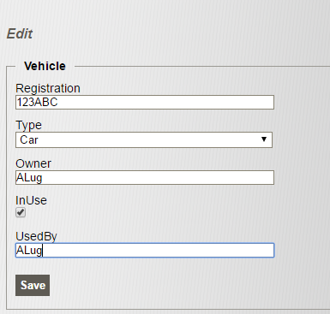

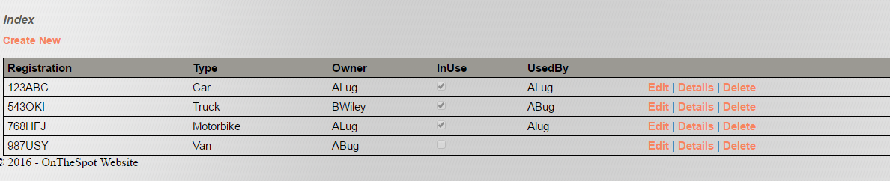

### Result

Pass – The courier is able to edit the status of a vehicle for deliveries.

## Overall Results

Test 1 – Pass   
Test 2 – Pass

Test 1 and Test 2 passed so the Story E-6 has been successfully implemented with a vehicles tab and enabled courier editing of availability.

# Story C-6: Account Management

As a customer, I want to be able to update my account details so that I can update address, contact details, and my password should the need arise.

## Acceptance Criteria

You can access and manipulate account settings without accessing the system framework  
Account settings include: Address, contact details and password.

## Test 1

The customer is able to change account settings.

### Evidence

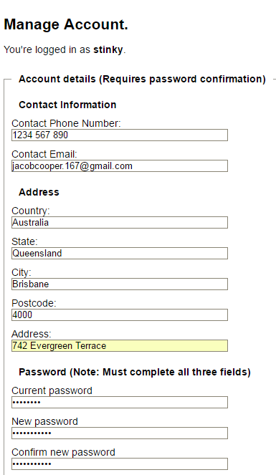  
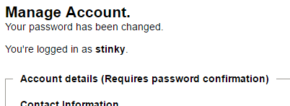

### Result

Pass – the password was successfully changed.

## Test 2

The changes made are updated in the administrator database.

### Evidence

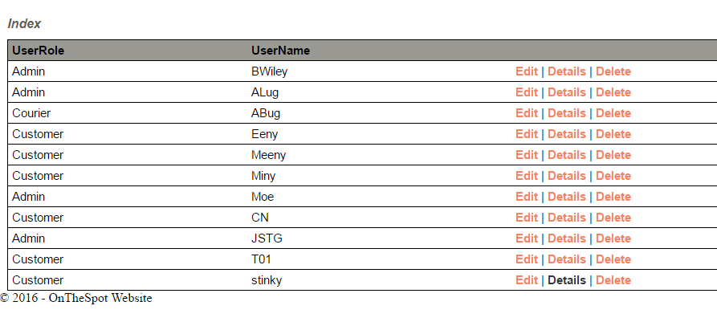  
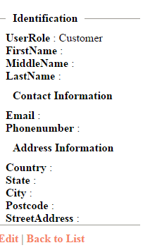

### Result

Fail – the changes/details were not present in the administrator user database.

## Overall Results

Test 1 – Pass  
Test 2 – Fail

Story C-6 has been implemented unsuccessfully as only one of two tests passed. The customer is able to change account details, as illustrated the password was changed, but the details of the account do not appear in the ‘Users’ tab for administrators.

# Story A-8: Staff Account

As an administrator, I want to be able to easily change a normal account to an employee or admin one so that I am able to hire more people as the company expands

## Acceptance Criteria

Able to indicate whether a given account belongs to another administrator or employee  
View of account is different once changed

## Test 1

An admin account is able to change the role of accounts in the ‘Users’ tab.

### Evidence

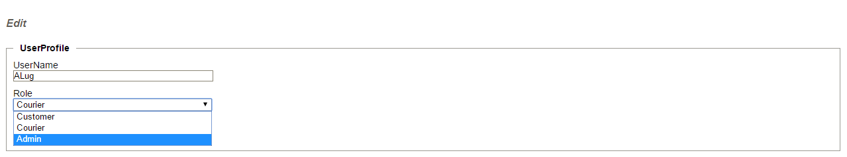

### Result

Pass – The former courier, ALug now has administrator accessibility and privilege.

## Test 2

Once the account has been changed, the account now has the updated accessibility.

### Evidence

  


### Result

Pass – Once the account was changed, the account now has admin accessibility.

## Overall Results

Test 1 – Pass  
Test 2 – Pass   
  
Story A-8: Staff Account has passed both acceptance tests meaning account accessibility can be updated to scale with new employees of the company